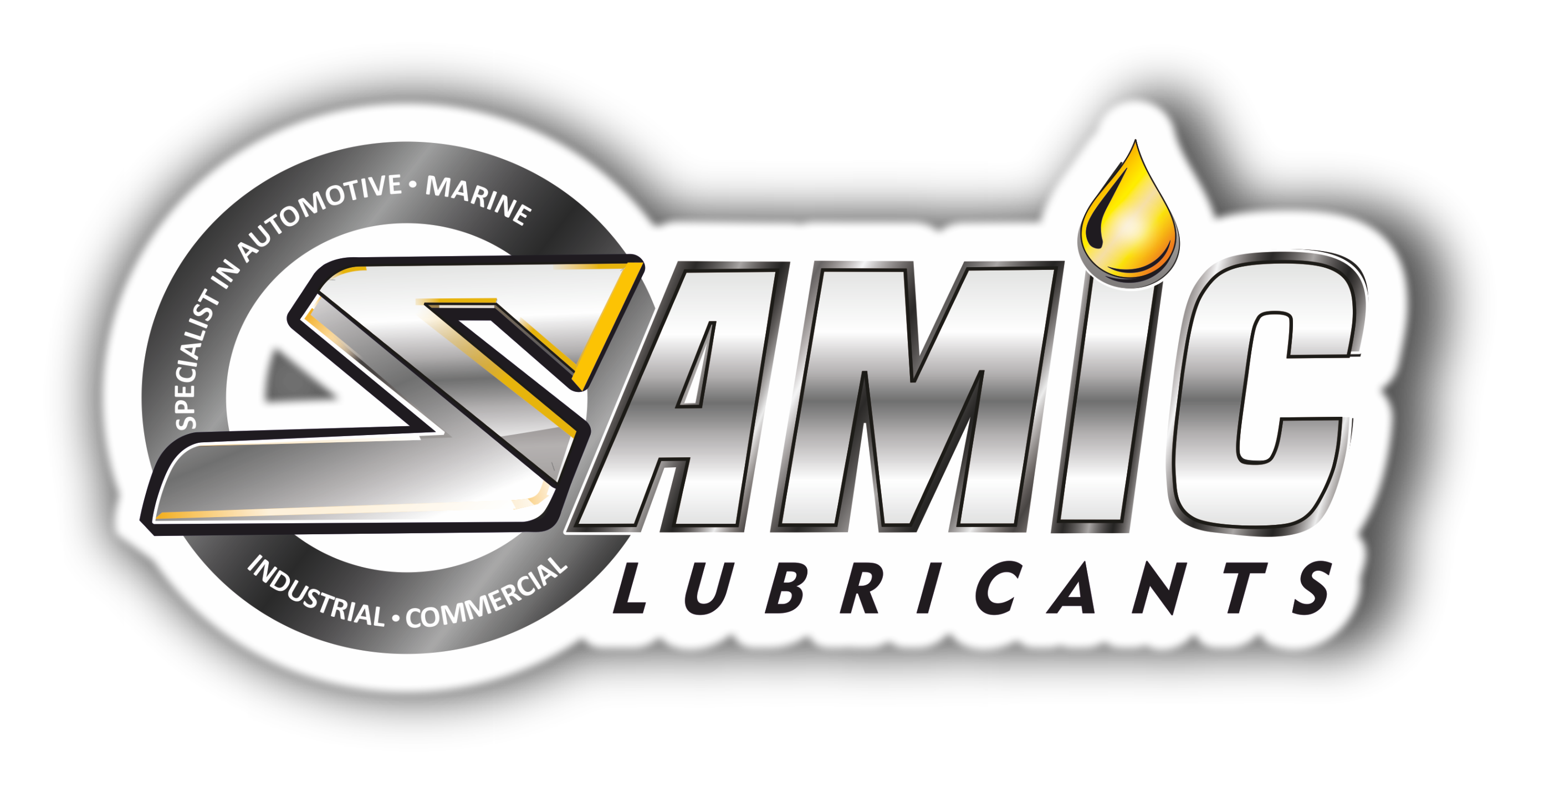

Samic Vital Jade C3 SN series
Advanced Performance Fully Synthetic Engine Oils

Product Data Sheet

Product Description
Samic Vital Jade C3 SN seires is a fully synthetic advanced performance engine oils blended in high performance synthetic basestocks fortified with advanced technology additive system, specifically formulated to provide exceptional cleaning power, wear protection and overall performance. It helps prolong the life and maintain the efficiency of Car Emission Reduction Systems in both diesel and gasoline powered automobile engines, with recent multi-valve engines equipped with turbochargers and direct injection fuel systems. Low content in Sulphated Ash, Phosphorus and Sulphur reduces particulate build up in Diesel Particulate Filters (DPF’s) and avoids poisoning of Gasoline Catalytic Converters (CAT’s)
Performance & Customer Benefits
- Optimization of the anti-pollution systems & extending its lifespan, especially the DPF’s & CAT’s.
- Excellent fuel economy & easy cold starts due to extreme fluidity at low temperatures.
- Advanced additive technology, reduces sludge formation which improves engine cleanliness.
- Excellent oxidation & thermal stability, helps in extending oil drain intervals.
- Outstanding engine protection, helps maintain longer engine life and greater compatibility with engine seals.

Specifications & Recommendations
Samic Vital Jade C3 SN series meets or exceeds following International and Builder specifications:
- API SN, CF • BMW Longlife-04 • MB 229.31
- ACEA C3/C2 • VW 502/505 • Porsche C30
OEM Approval: SAMIC VITAL JADE C3 5W30 SN holds MB-Approval 229.31

Main Application
Samic Vital Jade C3 SN series is suitable for use in following:
- Passenger cars, SUVs, light trucks and vans.
- Suitable for all types of modern vehicles, including high-performance turbo-charged, supercharged gasoline multi-valve fuel injected engines
- Excluded service includes - commercial and racing applications, frequent towing or hauling, extremely dusty or dirty conditions or excessive idling.

Typical Physical Characteristics
Samic Vital Jade C3 | Test Method | Units | 5W-30 | 5W-40
Density @ 15 ⁰C | ASTM D 4052 | gm/cc | 0.848 | 0.850
Viscosity @ 100 ⁰C | ASTM D 445 | cSt | 10.4 | 14.30
Viscosity @ 40 ⁰C | ASTM D 445 | cSt | 58.65 | 88.6
Viscosity Index | ASTM D 2270 | - | 169 | 168
Pour Point | ASTM D 97 | °C | -42 | -42
Flash Point (COC) | ASTM D 92 | °C | 220 | 228
Total Base Number | ASTM D 2896 | mg KOH/g | 7.6 | 7.6
Phosphorous | ASTM D 4951 | % wt | 0.078 | 0.078
CCS Viscosity | ASTM D 5293 | cP | 4560 @ -30 °C | 4650 @ -30 °C
The above figures are typical of blends with normal production tolerance and do not constitute a specification.

For further information, please contact: sales@samiclubricants.com

